

**Bachelor of Science in Computing**

**Software Engineering**

**Year 2022-23 / Semester 2**

Internal Examiner: Wei Ren

Internal Moderator: Wenhao Fu

External Examiner: Maria Barry

Date: 24/04/2023

Duration: 2 Hours

Time: 10:00-12:00

Exam Weighting: 60%

Exam Delivery: Computer

**Instructions**

1. This paper contains 1 section with 1 question.
2. You must attempt all parts of the question.
3. All questions are marked out of 100.
4. Please write all answers on the script provided.
5. Clearly number all questions.
6. This is an open-book exam.

***Please do not turn over this page until instructed to do so****. The use of programmable or text storing calculators is expressly forbidden. Please note that where a candidate answers more than the required number of questions, the examiner will mark all questions attempted and then select the highest scoring ones.*

**Question 1**

Please answer the question based on the following scenario: You are managing a software development team that has been invited by “Dorset Bank” to develop an operating system for their ATM machines. The ATM machines should allow clients to withdraw money at any time and deposit cash or checks. Additionally, the machines should display the client's account balance. You have 4 weeks to do this project.

1. Select a development method for this project and provide the reason for your choice, (e.g. waterfall development method, agile development method, etc.).

**[14 marks]**

**Answer:** For this application I would like to develop such an application with the Agile method. The Agile method is a process of creating, implementing and deploy programs in an organised manner. It aims is to clearly give out the objectives of a program which in return helps anyone involved in development understand what needs to be accomplished. The Agile method covers everything from requirements, implementation, design, deployment, testing and maintenance.

1. Provide a comprehensive list of the steps involved in the software development process.

**[5 marks]**

**Answer:** (1) Requirements

(2) Implementation

(3) Design

(4) Deployment

(5) Testing

(6) Maintenance

1. Write a requirement document based on the client's previous requirements, including functional requirements, interface requirements infrastructure requirements.

**[25 marks]**

**Answer:**

In order to write a good Requirement document, we must follow steps. These steps are explained in details below.

1. Functional requirements:

Dorset bank has giving us four weeks the develop a software for there ATM machine. From the time constraints I can infer that this software is most likely a low weighed application with few features and is not a wed application whoever it seems to be more like a console application.

This application should be able to withdraw money (at any time), deposit cash or checks and show account balance. We can also add that for a user to check his or her account they must first insert a card into the ATM machine. Upon doing this, this program checks if the card exists in its database. The database we will use in the application will be MySQL. This step is call user authentication, a type of security put in place to ensure program integrity.

1. Interface requirements:

The interface refers to visuals and we can break this down into 2 parts, the user interface and the code interface.

The user interface refers to the how the application should look like depending on the requirement of Dorset banks. For this application, we will need an initial screen to insert card and input pin. Validation takes place and the user is login in. We are then presented with all the options the user is able to do like check balance, insert cash or checks and so on. This is a brief explanation of how in user interface will look like for such an application.

The code interface covers how files are stored in you IDE. Code stored properly helps to prevent slow deployment and also helps when it comes to maintenance. This step is very important as it will save time in the future.

1. Infrastructure requirement:

This part also involves organisation. We need to know the tools necessary to complete the application. For this application we will use c# as my IDE, MySQL as my database. There will be no need for html or css as we do not have a front end to design. This is a console application. It is very important to understand the requirement or a project because to encourages organisation. A strong bed floor will be able to hold any weight.

1. Create a Use Case Diagram.

**[6 marks]**

**Answers:**

A user case diagram is created to make it easier for people who do not have programming sense to understand the idea. Below is a simple user case diagram that explains the idea behind the application

Insert card

|

(Bank to insert card) no < Enter pin > yes (login)

**|**

Show balance || withdraw money || insert money || logout

| | |

Balance Amount Amount

**| | |**

logout withdraws withdraws

**| |**

Logout logout

1. Create a Gantt Chart to manage development process.

**[10 marks]**

1. Provide an example code snippet, in any programming language, that includes the class name, function name, and any other necessary variables, to demonstrate how to achieve the goals of this project. You do not need to include the implementation details of the functions. Please show class diagrams or template code.

**[20 marks]**

**Answer:**

Below is a snippet of an ATM code for this application.

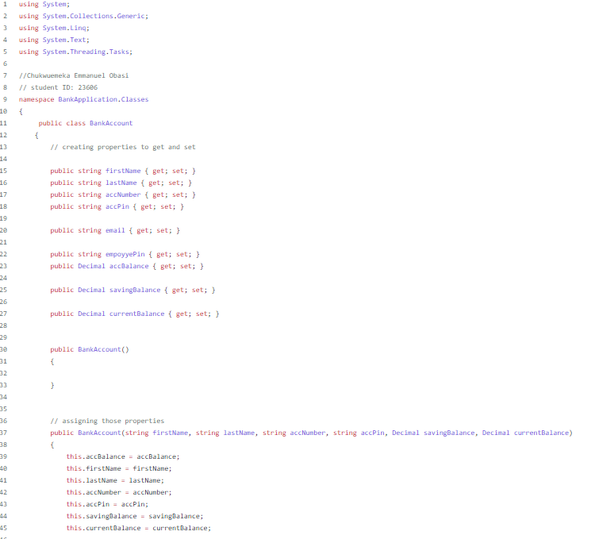

This is small example of setting up a bank application done in c#

1. Provide a detailed explanation of the validation and verification process that should be followed to ensure the successful completion of this project.

**[15 marks]**

**Answer:**

Validation and verification process include:

1. Requirement validation:

We must go through all the requirement and check if all the necessary requirement is covered. This step is to ensure satisfaction of the customer.

1. User testing validation:

After the application is finished, a user test validation must be carried out to check for any missed bugs. This step is done before deployment to make sure all the necessary functions are working at a minimalistic level.

1. Testing:

During coding, the back-end team must complete back end testing to ensure all links and pages are working before any form of deployment.

1. Deployment:

The application must now be deployed. This is to ensure after deployment, every and all functions still work as it should be. This step is done before the application is made available to the general public.

1. Maintenance: Frequent maintenance should be carried out every few months to keep the stander and integrity of the application. This is here because the application is now at a minimalist stage of deployment. That being said, the public will be quick to find bugs.
2. Create a repository on GitHub and upload your answers to it. Please note that the answers on GitHub will not be considered for marking, so it is essential to submit all your answers to Moodle before the exam deadline.

**[5 marks]**

**Answer: https://github.com/Emmanuel208/softwearExam.git**

**[Total 100 marks]**